The University of British Columbia | Okanagan
School of Engineering



CMPE-246, Computer Engineering Design Studio
Midterm Project Proposal
Lab Group T8
Section L2B
TA: Tixin Lu
Murat Guvenc, 34005223 (Software Lead)
Yanzie Adam Teodosio, 75400903
(Hardware Lead)
03/03/2026

1. Introduction

The objective of this project is to design and implement a Smart IoT Access Control and Attendance System using RFID technology and a Raspberry Pi. The system will allow users to scan RFID cards to gain controlled access to a secured door while automatically logging attendance data in a database.

Traditional attendance systems and access control mechanisms are often manual, inefficient, and lack real-time monitoring. Our project aims to provide an integrated hardware–software solution that combines embedded systems, backend development, database management, and web application design.
The system will consist of:

- An RFID reader for user identification

- A Raspberry Pi as the embedded controller

- A servo motor for door locking/unlocking

- A buzzer for feedback

- A Flask-based backend server

- An SQLite database

- A web-based administrative dashboard

This project integrates IoT, embedded systems, object-oriented programming, and web technologies into one unified system.

2. System Background and Theory

RFID (Radio Frequency Identification) works by using radio waves to detect tags. The RC522 RFID reader operates at 13.56 MHz and communicates with the Raspberry Pi using SPI. Each RFID card has a unique ID (UID).

When a card is scanned:

- The reader detects the UID.

- The Raspberry Pi sends the UID to the backend server.

- The backend checks the database.

- If valid, the servo unlocks the door and attendance is recorded.

The servo motor is controlled using PWM signals from the Raspberry Pi. The buzzer gives feedback for valid or invalid scans.

For the backend, we will use Flask API to create the routes and SQLite to store users and attendance records. The frontend dashboard will allow an admin to view logs, register users, and export data as excel or csv.

3. Team Responsibilities
Hardware – Adam
- Connect RFID module
- Connect servo and buzzer
- Calibrate servo angles
- Test unlocking mechanism
- Ensure stable power and wiring
- Connect hardware scripts to backend

Software– Murat
- Design SQLite database
- Develop Flask backend
- Create API for card validation
- Implement attendance logging
- Build web dashboard
- Implement admin authentication
- Add data visualization
- Optimize and refactor code

We divided tasks based on strengths: one focusing on hardware, the other on backend and web development.

4. Project Plan and Timeline
Project Overview
This project will be developed in two main phases:
- Phase 1 (Week 8): Proposal Finalization and System Design
- Phase 2 (Weeks 9-12): Implementation, Integration, and Testing

The objective is to design, implement, and demonstrate a fully functional RFID-based access control system with database logging and an administrative dashboard.

Phase 1: Proposal and System Design
Lab 5 - Week 8
Objective: Finalize System Design and Planning
During this phase, the project scope and architecture will be finalized.

Activities:
- Define system architecture and block diagram
- Identify hardware components
- Design database schema
- Assign team responsibilities
- Develop implementation strategy
- Prepare and submit final proposal

Deliverables:
- Approved project proposal
- System block diagram
- Database schema draft
- Component list

Phase 2: Implementation and Integration
Lab 6 – Week 9
Objective: Hardware Setup and Basic Functionality

This phase focuses on implementing and validating core hardware components.

Activities:
- Configure RFID module using SPI interface
- Implement card UID reading
- Integrate and test servo motor (PWM control)
- Integrate buzzer feedback system
- Develop basic local authentication logic (hardcoded validation)
- Verify door unlock sequence

Milestone: A standalone prototype where scanning a valid RFID card unlocks the servo-based door mechanism.

Lab 7 – Week 10
Objective: Backend Development and Database Integration
This phase transitions from local logic to database-driven validation.
Activities:
- Develop SQLite database
- Create Users and Attendance tables
- Implement Flask backend server
- Create API endpoint for card validation
- Log timestamped attendance entries
- Connect RFID reader to backend via HTTP requests
Milestone: RFID scan triggers backend validation and logs attendance data in the database.

Lab 8 – Week 11
Objective: Dashboard Development and Full System Integration
This phase completes system functionality.

Activities:
- Develop administrative login interface
- Implement attendance log display page
- Create user registration interface
- Implement CSV export functionality
- Conduct full system integration testing

Milestone: Fully integrated system with functional web dashboard and database logging.

Lab 9 – Week 12
Objective: Testing, Optimization, and Enhancement
The final implementation phase focuses on reliability and refinement.

Activities:
- Perform stress testing (multiple rapid scans)
- Improve error handling and validation
- Optimize system response time
- Refactor and organize backend code
- Optional enhancement (if time permits):
- Anti-passback logic
- Occupancy counter
- Finalize physical wiring and presentation setup

Milestone: Stable, demo-ready system with complete documentation.

5. Resources
Hardware:
In terms of hardware, our physical design does not require too many components to ensure that we have a functional baseline while having the possibility of new features for our system. For the baseline of our prototype as mentioned in the function of our project we would require:
- Card Reader Module for RFID RC522 with S50 13.56MHz
- RFID Cards and Chip Key Ring
- Servo Motor
- Active Buzzer
- Push Button and LED

In addition with a Raspberry PI 4 kit which gives us additional components for improving our design. For online resources, we’ll be using the instructables website and Youtube videos for hardware components which gives us demonstration and troubleshooting for our components as we work through its development.

Software:
For the software side, we will mainly use Python to control Raspberry Pi and handle communication between the hardware components and the backend system. The backend will be developed using Flask, which will process RFID scans and validate them through the database.

We will use SQLite to store user information and attendance records since it's very lightweight and easy to integrate with Python. For the dashboard interface, HTML, CSS and JavaScript will be used to display attendance logs and allow basic admin interaction. The project development and collaboration will be managed using GitHub for version control.

6. Design Approach
6.1 Design Patterns for Project Ideation and Prototype Development
Our proposed Smart RFID-Based Access and Attendance system was developed to target common difficulties when using conventional systems. Some common difficulties are the lack of automation, real-time logging, and monitoring capabilities which can result in inefficiencies and security vulnerabilities. To address these challenges, our group proposes an embedded IoT-based system that integrates RFID authentication, automated door control, database-driven attendance logging, and administrative dash board. The goal is to create a scalable and modular system that bridges hardware interaction with backend data management.

The system architecture of our proposal follows a modular design pattern, where the system is composed of logical subsystems with dedicated function. These subsystems include the authentication module, the actuation module, the feedback module, the backend validation module, the data management module, and the presentation layer. This ensures clear boundaries between hardware and software control, and user interaction. This allows for maintainability, simplify debugging, and modularity when it comes to improving the system.

For building our prototype, we plan to validate and test each subsystem before we integrate everything into a system. The first stage is to validate the hardware system, where the RFID reader, servo motor, and buzzer are tested individually to ensure reliable operation. The second stage introduces local authentication logic, where the system is fully functional without backend integration. The third stage will be integrating the database and backend server, enabling attendance logging and validation. The final stage will focus on optimization, system testing, and implementing the design in a physical structure. This reduces the risk of integration, improves isolation of any errors in our subsystems, and ensures that a functional baseline is maintained throughout the development.

6.2 Solutions Demonstrating Object-Oriented Design and Development
We will implement object-oriented programming principles to ensure modularity, scalability and maintainability of our prototype. For our system, functionality is encapsulated into well-defined classes that represent the core components of the system.

Instead of putting everything in one file, we will separate logic into classes like:
- RFIDReader - which manages card detection and UID retrieval
- DoorController - controls the servo-based locking mechanism
- DatabaseManager - handles database operations
- AttendanceManager - handles attendance logic (ie. prevent duplicates, check entry/exit rules)

This encapsulation ensures that each class maintains control over its internal state and hardware-specific operations. makes the code cleaner and easier to debug.

We will also follow an MVC-style structure:

- Models → Database
- Views → HTML pages
- Controllers → Flask routes

Using GitHub for version control will help us collaborate and track changes.

System Design
The system has four main parts:

Hardware Layer
- RFID RC522
- Servo motor
- Buzzer
- Raspberry Pi

Logic Layer
- Python scripts for RFID reading
- Servo control
- Communication with backend

Backend Layer
- Flask server
- SQLite database
- API endpoints

Frontend Layer
- Web dashboard
- Admin login
- Attendance display
- Charts using Chart.js
- Database Structure

We will use two main tables:
- Users
- id
- name
- rfid_uid
- role
- Attendance
- id
- user_id
- timestamp
- status (granted/denied)

This allows us to link attendance records to specific users.

7. Expected Results
By the end of the project, we expect:

- RFID validation working consistently
- Door unlocking within about 1 second
- Attendance stored correctly in database
- Dashboard showing real-time logs
- Admin able to manage users
- CSV export functionality

We will also include diagrams and screenshots in the final submission.

8. Reflection
This project is different from regular labs because it combines many topics together: embedded systems, networking, databases, and web development. The most challenging part will likely be making sure hardware and backend communicate smoothly without delays or crashes. We also need to make sure the system is reliable when multiple scans happen quickly. Overall, this project gives us practical experience in building a complete IoT system from start to finish, not just isolated components.

9. Appendices
->9.1 UML Class Diagram:
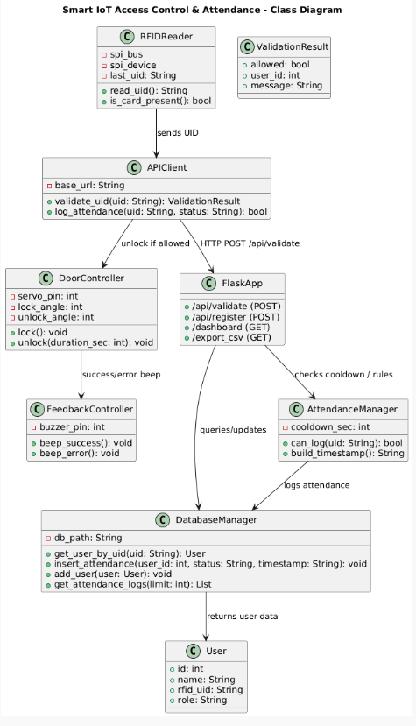

->9.2 UML Sequence Diagram: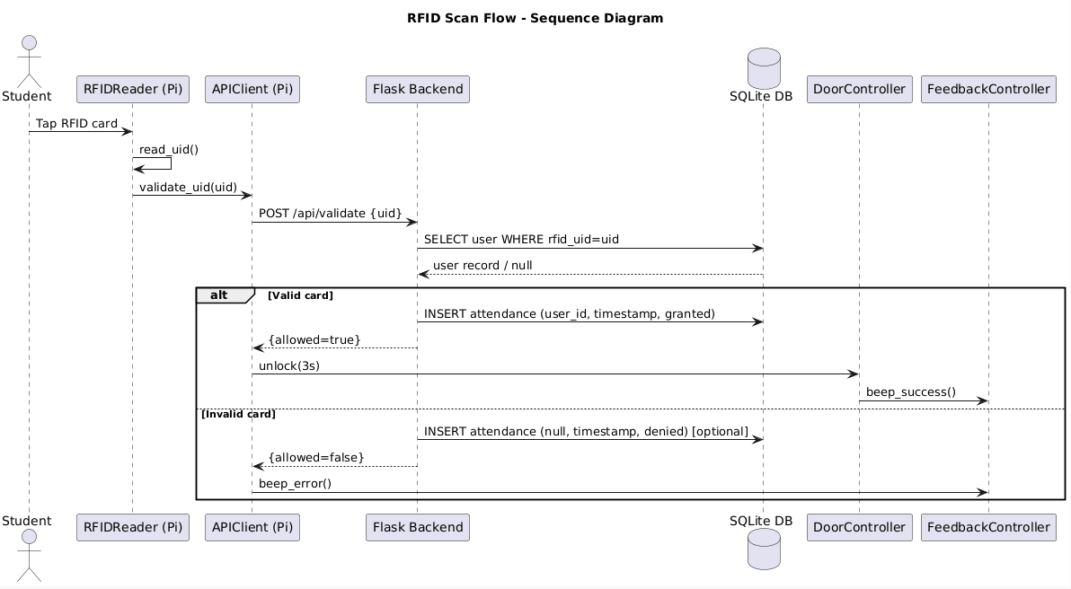

->9.3 UML Component Diagram: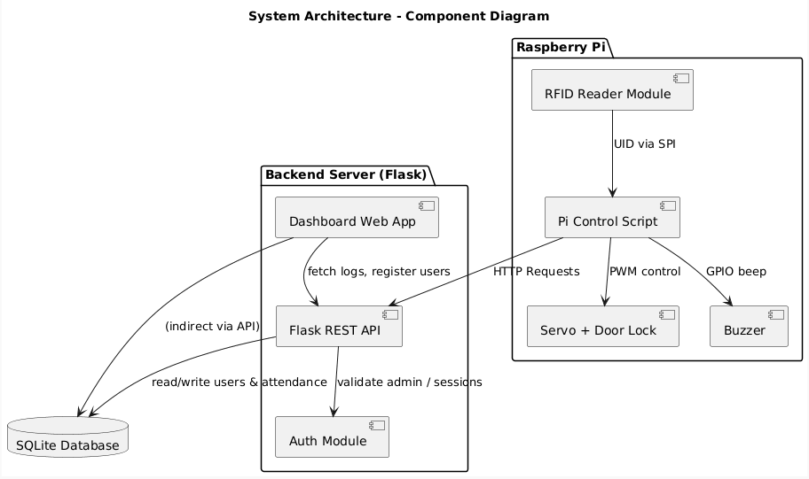

10. Github Repository

Our project code and documentation are maintained in a public GitHub repository:

https://github.com/tmugu/cmpe246_project.git

The repository will store the source code, system diagrams, and development updates for the project.

